SKIN-LEVEL 0ASTROSTOMY INDWELLING FEEDING DEVICE

PURPOSE

A gastrostomy is a surgical opening into the stomach through the surface of the abdomen. The skin-level gastrostomy feeding device is a "T"-shaped plastic device held in place by a mushroom-shaped dome or fluid-filled balloon inside the stomach. The device remains in place at all times and is capped by an attac hed safety plug between feedings. In addition, the dome has an antireflux valve to further prevent leakage of stomach contents. A feeding is administered by inserting a small tube into the device. When the feeding is complete, the tube is removed and the safety plug closed.
The gastrostomy device may be used to ad.minister food, fluids, and/or medications directly into the stomach. This method is used to bypass the usual route of feeding by mouth when
- There is an obstruction of the esophagus (i.e., food pipe).
- Swallowing is impaired, and thestudent is at risk for choking/aspiration.
- The student has difficulty taking enough food by mouth to maintain adequate nutrition.
A student may receive a gastrostomy feeding by either bolus or continuous, or slow­ drip, method. A bolus is a specific amount of feeding given at one time (over 20-30 min­ utes). A slow drip, or continuous, feeding is given slowly over a number of hours.
The gastrostomy device also may be used to drain abdominal contents or to release air or gas when venting is required. This is done by inserting a special adaptor or tube to open the antireflux valve.

SUG GEST ED SETTINGS

There are no restrictions as to when a student may be fed. The student may be fed with other students or, if he or she prefers,
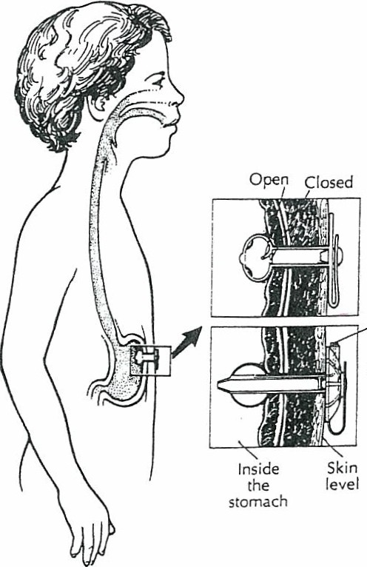in a more private setting (e.g., the health room). Some students receive feedings every 2-3 hours. These stu­ dents may have their feedings admin­ istered in the classroom. They need to remain stationary and should be able to continue sedentary school activi­ ties (e.g., reading, doing·art, singing, working on the computer, learnin g social stu dies).
Ba lloo n inflation port
Some students do not require feedings during the school hours. Their devices are used to supplement oral intake of food and fluids or are used when the student is ill or oral intake is not adequate.
For students whose gastrostomy devices require venting or drainage, the procedures should be done in the

health room or another private area. These procedures may be done after each feeding or according to physicians' orders.
Gastrostomy devices usually are covered by clothing. Students with these devices should be able to participate in all school activities, but participation in physical educa­ tion should be determined on an individual basis and may require modification of activ­ ities.

SUGGESTED PERSONNEL AND TRAINING
A health assessment must be completed by the school nurse. State nurse practice regu­ lations should be consulted for guidance on delegating health care procedures.
A gastrostomy device feeding may be administered by the school nurse, parent, teacher, student's aide, or other staff person with proven competency-based training in appropriate techniques and problem management. The student should be encouraged to assist with the feeding as much as possible.
School personnel who have regular contact with a student who has a skin-level gas­ trostomy feeding device should receive general training that covers the student 's spe­ cific health care needs, potential problems, and how to implement the established emergency plan.

THE INDMDUALIZED HEALTH CARE PIAN: ISSUES FOR SPECIAL CONSIDERATION

For a student with a skin-level gastrostomy device, thefollowing items should receive particular attention:
  - Size and type of feeding device
  - Type of portable pump
  - Type of feeding the student is receiving (e .g., bolus/continuous drip)
  - Activity level after feeding
  - Positioning during and after feeding
  - Determining the need to measure gastric residuals
  - Determining the need to vent the gastrostomy device (familiarity with student­ specific device and venting method)
  - Patency of gastrostomy tract and time frame for reinsertion of the device should it fall out
  - Monitoring concerns regarding feeding (e.g., vomiting, abdominal distension, pain)
  - Amount of food and fluid a student can take by mouth
  - Amount of oral stimulation during feeding, as ordered
  - Procedure should tube come out
- Student-specificguidelines for feeding administration during transport
- Latex allergy alert (see Chapter SJ
- Universal precautions (Anticipating the tasks to be done, the risk involved and the personal protective equipment needed will enhance protection of both the aregiver and student.)
- Manufacturer's specific directions

0ASTROSTOMY TUBE

PURPOSE

A gastrostomy is a surgical opening into the stomach through the surface of the abdomen.
The gastrostomy tube (G-tube) is a flexible catheter held in place by a balloon or a widened flat "mushroom" at the tip of the tube inside the stomach. The tube remains in place at all times and is closed between feedings to prevent leakageof stomach contents. G-tubes cause no discomfort.
The G-tube may be used to administer food and fluids directly into the stomach.
This method is used to bypass the usual route of feeding by mouth when
- There is an obstruction of the esophagus (i.e., food pipe).
- Swallowing is impaired, and the student is at risk for choking/aspiration.
- The student has difficulty taking enough food by mouth to maintain adequate nutri- tion.
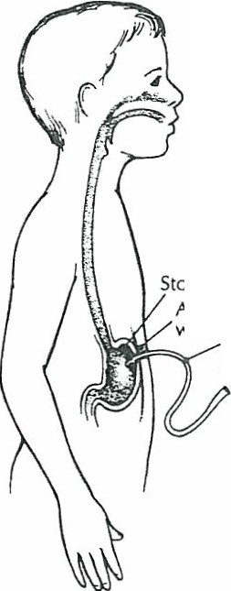
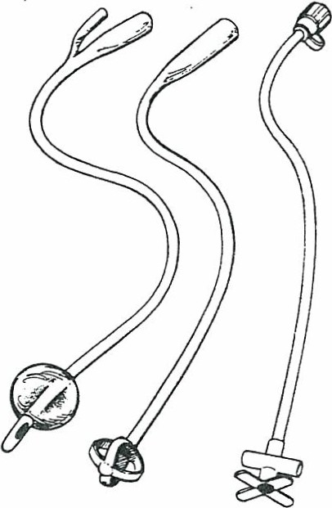
A student may receive a G-tube feeding by either the bolus or continuous (slow-drip) method. A bolus is a specific amount of feeding given at one time (o ver 20-30 minutes). A slow drip is a feeding that is given slowly over a number of hours, running continu­ ously.

Stomach Abdominal
wall Gastrostomy tube

The G-tube may be used to drain abdominal contents or to release air or gas when venting is required.

SUGGESTED SETTINGS
There are no restrictions as to where a student may be fed. The setting should be clean and appropriate to the student's need/desire for privacy. The student may be fed with other students or, i£ he or she prefe rs, in a private setting (e.g., the health room). Some students receive feedings every 2- 3 hours. These students may have their feedings administered in the classroom. They need to remain stationary and should be able to continue sedentary school activities (e.g., reading, doing art, singing, working on a com­ puter, learning social studies ).

Some students do not require feedings during the school hours. Their G-tubes are used to supplement oral intake of food and fluids or are used when the student is ill or when oral intake is not adequate.
For students whose G-tubes require venting or drainage, the procedures should be done in the health room or another private area. These procedures may be done after each feeding or according to physicians ' orders.
G-tubes usually are covered by clothing. Students with G-tubes should be able to participate in all school activities, but participation in physical education should be determined on an individual basis and may require modification of activities.

SUGGESTED PERSONNEL AND TRAINING
A health assessment needs to be completed by the school nurse. State nurse practice reg­ ulations should be consulted for guidance on delegating health care procedures.
AG-tube feeding may be administered by the school nurse, parent, teacher, stu­ dent's aide, or other staff person with proven competency-based training in appropriate techniques and problem management. The student should be encouraged to assist with the G-tube feeding as much as possible.
School personnel who have regular contact with a student who has a G-tube should
- receive general training that covers the student's specific health care needs, potential problems, and how to implement the established emergency plan.

THE INDMDUALIZED HEALTH CARE PLAN: ISSUES FOK SPECIAL CONSIDERATION

For a student with a G-tube, the following items should receive partic­
ular attention:
  - Size and type of feeding device
  - Type of portable pump
  - Type of feeding the student is receiving (e .g., bolus/continuous drip; liquid formula- pureed/liq ui.fied food from home)
  - Activity level after feeding
  - Positioning during and after feeding
  - Determining the need to measure gastric residuals
  - Determining the need to vent the G-tube
  - Patency of gastrostomy tract and time frame for reinsertion should the G-tube fall out
  - Monitoring concerns !e.g., vomiting, abdominal distension, pain)
  - Amount of food or drink a student can take by mouth
  - Amount of oral stimulation during feeding, as ordered
  - Medications and schedule for administering
  - Student-speci fic guidelines for feeding administration during transport
  - Latex allergy alert (s ee Chapter SJ
  - Universal precautions (Anticipating the tasks to be done, the risk involved, and the personal protective equipment needed will enhance protection of both the caregiver and student .)
  - Manufacturer's specific directions

PROCEDURE FOR 0ASTROSTOMY TuBE FEEDING-­ SLOW-DRIP METHOD OR CONTINUOUS FEEDING BY PUMP

PROCEDURE

Wash hands.

- 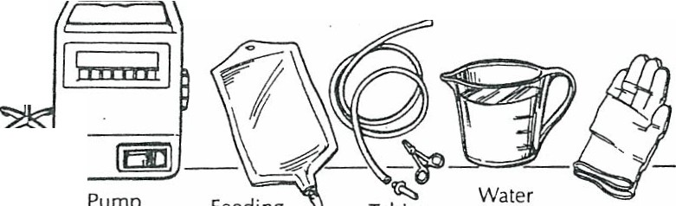Assemble equipment:

Jl_j2_--
Liquid IV pole
POINTS TO REMEMBER

Anticipating the tasks to be done, the risk involved, and the personal protective equip­ ment needed will enhance protection of both the caregiver and student.

feeding Syringe Gloves
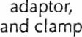
solution

  - Liquid feeding solution/formula at room Identify size and type of G-tube. Some stu-

temperature dents get cramps i f the feeding solution is too cold. Shake can well to mix. Check expiiation date.

  - 60-ml or -cc catheter-tipped syringe
  - Feeding pump and IV s tand (optional)

  - Clamp or cap for end of tube (optional)
  - Water (if prescribed)
  - Feeding bag and tubing
  - Rubber bands and safety pins
  - Gloves (optional)
- Explain the procedure to the student at his or her level of understanding. Encour­ age the student to participate as much as possible.
- Position student.

- Wash hands. Put on gloves.
- Remove cap or plug from G-tube and insert a catheter-tipped syringe into the end of feeding tube.

Feeding pumps have alarms. Become familiar
- with meanings of alarms and how to respond to them.

Used to flush tubing after feeding. Used to secure G-tube to clothing.
By encouraging the student to assist in the pro­ cedure, the caregiver helps the student achieve maximum self-help skills.

Student may be sitting or lying on right side with head elevated at a 30-degree angle. When positioning student, make sure clamp is not pressing on skin. Remember to unpin G-tube before proceeding with feeding.

G-tube is still clamped. Do not apply undue traction or pull on gastrostomy tubing.

- Unclamp the tubing and gently draw back on the plunger to remove any liquid or medication that may be left in the stomach (i.e., residuals1. Look at amount in tube and push fluid slowly back into stomach.

- Clamp the gastrostomy tubing. Disconnect the syringe.
- Pour feeding/fluids into feeding bag and run feeding through bag and tubing to the tip. Clamp.
- Hang bag on pole at height required to achieve prescribed flow. If a feeding pump is used, place tubing into pump mecha­ nism and set for proper flow rate.
- Insert tip of feeding bag tube into G-tube, tape securely. Unclamp G-tube.
- Open clamp of feeding bag tubing and adjust until drips flow at prescribed rate.

- For continuous feeding with pump, add more fluid to bag when empty.
- When single feeding is completed (bag
empty), clamp feeding bag tubing, and clamp G-tube.

Be alert to any unusual changes in the studen s tolerance of the feeding. Nausea/vomiting, cramp­ ing, or diarrhea may indicate that the feeding is being given too quickly or formula is too cold.

- Disconnect feeding bag from G-tube.
- ·u nclam p G-tube and flush with water if
ordered, using a syringe.
- Vent G-tube if indicated. (Open G-tube to
air.)
- Clamp and cap G-tube.

- Apply dressing, if needed, using universal precautions

Note the amount that was withdrawn from the feeding tube. Adjust the feeding volume according to physician's orders if a residual is present. If th e residual is greater than rec­ ommended, hold feeding, wait 30--45 min­ utes, and check again. Some students may not need to have residuals checked.

If medication is prescribed, administer before or afrer feeding, according to student-specific guidelines.
School activities may continue during feeding provided the student is sedentary.

Do not apply undue traction on gastrostomy tubing.
I f feeding pump is used, open clamp com­ pletel y. Check flow periodically and adjust if needed.

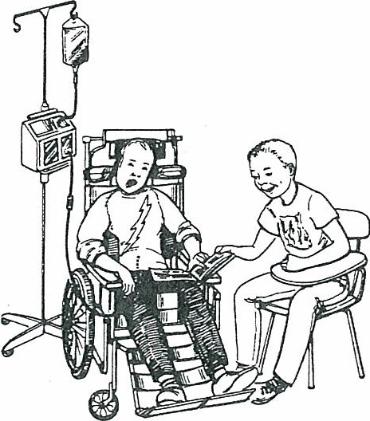

This clears the tube of any feeding fluid. Some students may have gas otherwise.

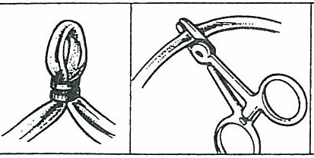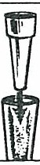
Rubber band Clamp Plug

- Make sure tubing is secure and tucked inside clothing, not inside diaper or under­ pants.
- Refer to student-specific guidelines regard­ ing position and activity after feeding.

- Wash syringe and other reusable equip­ ment in soapywater. Rinse thoroughly, dry, and store in a clean area.

- Document feeding and/or medication, residual volumes, and feeding tolerance in log.

Tubing may be pinned or taped to shirt.

The feeding tube may be disconnectedwhile the student is being transported to and from the school program.
Most open formula is good for 48 hours. The exceptionsare some elemental formulas th at are good for only 24 hours. Open formula should be stored in clean plastic, labeled containers (no t the original can) in the refrig­ erator. Formula should be discarded after
48 hours.
Report to family any change in the student's usual pattern.

Possible Problems that Require Immediate Attention
Observations Reason/Action

Color ch anges/breathing difficulty

This may be due to aspiration of feeding into lungs. Stop feeding im mediately. Call nurse if not present. Assess situation. I f problem continues, institute emergency plan and notify family.

Possible Problems that Are Not Emergencies

Observations
Nausea and/or cramping

Vomiting

Blocked gastrostomy tubing

Redness/irritation/bleeding/drainage

- tube falls out

Reason/Action

Check rate of feeding- it may need to be decreased.
Check tem perature- formula may be too cold: stop feeding, let feeding get toroom tempera­ ture, then administer. I f problem continues, notify school nurse, family, and physician.
If all the above have been checked, stop feed­ ing, call school nurse or family. Rem ove residual if ordered.
May be due to inadequate f].ushing or very thick f].uid. Squeeze or roll gastrostomy tubing with fingers moving slowly down toward student's stomach. Try a catheter­ tipped syringe filled with warm water, held high to facilitate movement of f}.uid. Try to draw back plungerof syringe. If blockage remains, contact schoolnurse or family.
Make sure tubing is not being pulled. Check G-tube site for leakage.
Clean stoma site i f leakage of food/f].uid/ medication comes in contact with skin.
Refer to student - or equipment-specific guide ­ lines for cleaning instructions.
Noti fy school nurse and family of gastrostomy site problems.
The G-tube may need to be reinserted immedi ­ ately if a student' s tract closes quickly.
Cover the site with a dry dressing or large bandage. Notify family.

PROCEDURE FOR 0ASTROSTOMY TUBE FEEDING­ BOLUS METHOD

PROCEDURE
  - Wash hand.s.

  - Assembl e equipment:
-• , _)o_
Liquid . Plug
ieeding Syringe or
solution clamp

    - Liquid reeding solution/ formula at room temperacure

    - 60-ml or -cc catheter-tipped syringe or other container for feeding
    - Clamp or cap for end of tube (optional)
    - Water 1ii prescribed)
    - Rubber bands and safety pins
    - Gloves ,optional)
  - Explain the procedure to the student at his or her level of un derstanding. Encour­ age the scudent to participate as much as possible.
  - Position student.

  - Wash hand.s. Put on gloves.
  - Remo ve cap or plug from G-tube and insert a catheter-tipped syringe into the end of feeding tube.
  - Unclamp the tubing and gently draw back on the plunger to remove any liquid or medication that may be left in the stomach (i.e., residua.ls) . Return residuals to stom­ ach (if ordered).

  - Clamp the tubing, disconnect the syringe, and remove plunger from syringe.
  - Reinsert catheter tip of syringe into tubing.
POINTS TO REMEMBER
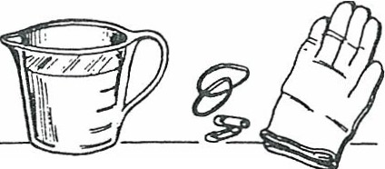
Anticipating the tasks to be done, the risk involved, and the personal protective equi p­ ment needed will enhance protection of both the caregiver and student.

Rubber bands
Water
and Glo ves
safety pins

Identify size and type of G-tube. Some stu­ dent s get cramps if the feeding solution is too cold. Shake can well to mix. Check expi.Iation date.

Used to flush tubing aft er fee ding. Used to secUie G-tube to clothing.

By encouraging the student to assist in the procedure, the caregiver helps the student achieve maximum self-care skills.

Student may be sitting or lying on right side with head elevated at a 30-degree angle. When positioning student , m ak e sUie clamp is not pressing on skin. Tubing may be pinned to shiILRemember to unpin G-tube before proceeding with fee ding.

- tube is still clamped. Do not pull on tubin g.

Note the amount that was withdrawn from the feeding tube. Ad just the feeding volume according to physician's orders if a residual is present. I f the residual is gu ater than recommended, hold feeding, wait 30-45 minutes, and check again. Some students may not need to have residuals checked.

Syringe should be held 6 inches above level of stomach or at prescribed height .

).0. Unclamp tube, and allow bubbles to
escape.
- Pour feeding/fluid into syringe and allow to flow in by gravity.

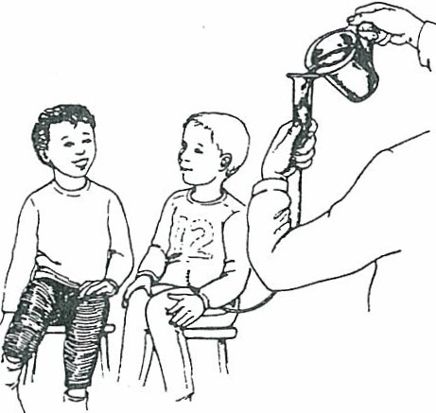
- Continue to pour feeding into syringe as contents empty into stomach.

- Raise or lower syringe or container to adjust flow to prescribed rate.
- When feeding is completed, pour pre­ scribed amount of water into syringe, and flush tubing.
- Vent G-tube if ordered. (Open G-tube to
air.)

- Clamp tubing, remove barrel of syringe, and reinsert cap into end of tubing.

- Apply dressing, if needed, using universal precautions described in Chapter 5.
- Remove gloves. Wash hands.
- Make sure tubing is secure and tucked inside clothing, not inside diaper or under­ pants.
- Refer to student-specific guidelines regard­ ing position and activity after feeding.
- Wash syringe and other reusable equip­ ment in soapy water. Rinse thoroughly, dry, and store in a clean area.

- Document feeding/medication, residual amount, and feeding tolerance on log sheet.

If medications are prescribed, admin ister before or after feeding, according to student­ specific recommendations. If a container other than a syringe is used for the feeding, unclamp tubing and allow to flow in by gravity, using the same procedure.

Be alert to any changes in the student's tolerance of the feeding. Nausea/vomiting, cramping, or diarrhea may indicate that the feeding is being given too quickly or the formula is too cold. ""

Depending on the age and capabilities of the student, havehim or her assist with the feed­ ing by holding syringe or pouring fluid into it. Keep syringe partially filled to prevent ai.I from entering stomach.

This will clear tubing of feeding and medica­ tion.

Venting allows drainage of fluid or release of gas bubb les in the stomach. Some students may have problems with gas otherwise.

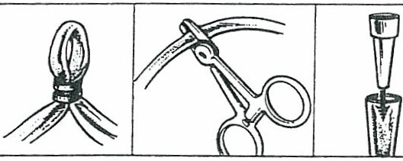
Rubber band
Clamp
Plug

Tubing may be pinned or taped to shi.It if par­ ent follows this practice.

Most open formula is good for 48 hours. The exceptions are some element al formulas that are good for only 24 hours. Open formula should be stored in clean plastic containers. labeled correctly (n ot the original can) in
the refrigerator. Formula should be discarded aft.er 48 hours.
Report to family any change in the student's usual pattern.

JfilUNOSTOMY TuBE

PURPOSE

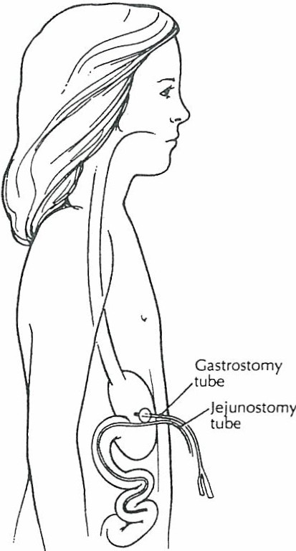
A jejunostomy is a surgical opening into the jejunum (i.e., the small intestine between the duodenum and the ileum) through the surface of the abdomen. The jejunostomy tube (J-tube) i s a flexible, rubber or latex catheter that is held in place on the abdominal wall with tape or is fed through the gastrostomy site through theintestine down to the je jun um and taped to the G-tube. The tube remains in the small intes­ tine at all times and must not move in or out. The J-tube causes no discomfort when in place.
The jejunostomy tube may be used to adminis­ ter food and fluids directly into the je jun um . This method is used to bypass the usual route of feeding by mouth and stomach when
- There is blockage in the upper esophagus and/or stomach.
- The student is at risk for aspiration and gastro­ esophageal reflux.
- The student has difficulty taking enough food by mouth or gastrostomy feedings to maintain ade­ quate nutrition.
- The student has intestinal pseudo-obstruction or short bowel syndrome.
- The student has had major stomach surgery or a problem with stomach emptying.
- The student has a depressed gag reflex.

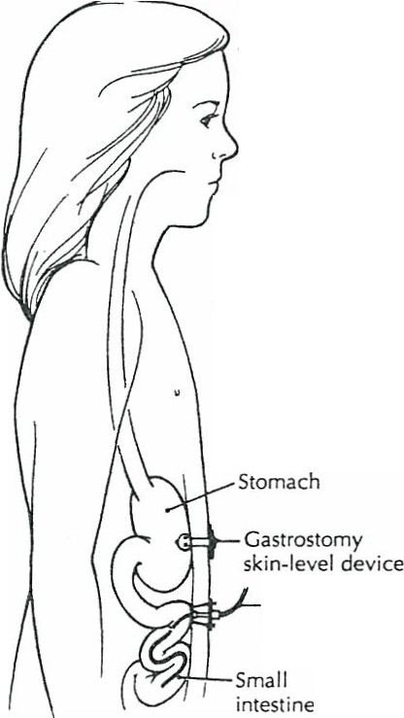A student receives jejuna! feeding by continuous drip method slowly over a number of hours. The continuous drip method is preferred over the bolus method to prevent giving a large vol­ ume of feeding over a short period of time.
.
....
""'
""'
..
,,
/r"-..
• ('I.
Je juno sto my site
I
Jejunostomy tube
In addition to J-tubes, gastros­ tomy skin-level feeding devices ap.d

cally to provide direct jejuna! feeding.
Factors affect ing selection of thes e devices are the student 's age, the size of the device, and whether the student is allergic to the material of the device. Some students may have a G-tube and a J-tube in the same stoma. There may be two distinctly separate tubes or one tube with several identified ports. Some students may have a gastros­ tomy device and a jejunostomy device and will have two distinct abdominal

stoma sites. In most cases, the gas­ trostomy device will be vented for comfort, and in many situations, the venting is continuous.
The gastrojejunal tube is a single tube with three limbs, including
  - A jejuna!feeding port (i.e ., the open­ ing of the tubing into the jejunum)
  - A gastric port (i.e., the opening of the tubing into the stomach)
  - A balloon inflation limb (holds the tube in place)
There is one abdominal stoma (gas­ trostomyJ, and the device passes through the gastrostomy and stom­ ach and into the jejunum. Other stu­ dents may have an NG-tube or other small tube inserted through the gas­ trostomy stoma alongside the G-tube and into the jejun u m.

Je junal po rtion o f tube
GASTROJEJU NAL TUBE
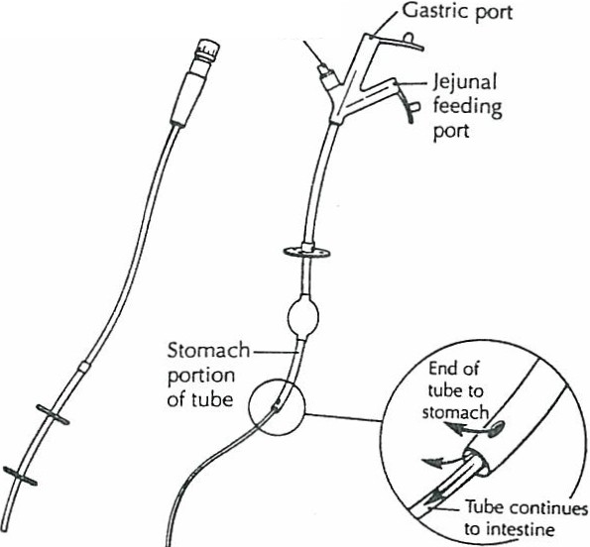JEJ UN AL B_a llo_no '
TUBE inflatio n
limb

SUGGESTED SETTINGS

There are no restrictions as to where a student may be fed. The student may be fed with other students, or, if the student prefers, in a more private setting (e.g., health room). Some students receive feedings every 2-3 hours. These students may have their feed­ ings administered in the classroom. They may need to remain stationary and should be able to continue sedentary school activities (e.g., reading, doing art , singing, working on a computer, learning social studies). Some students do not require feedings during school hours.
For students whose gastrostomy tubes require venting or draining, the procedures should be done in the health room or another _private area. These procedures may be done after each feeding or according to physician's orders. Some children may have the gastrostomy tube vented continuously to a small drainage bag.
J-tubes usually are covered by clothing. Students with J-tubes should be able to par­ ticipate in all school activities, but participation in physical education should be deter­ mined on an individual basis (especiallyfor those with J-tubes taped to G-tubesJ.

SUGGESTED PERSONNEL AND TRAINING

A health assessment must be completed by the school nurse. State nurse practice regu­ lations should be consulted for guidance on delegating health care procedures.
A jejunostomy feeding may be administered by the school nurse, parent, teacher, student's aide, or other staff person with proven competency-based training in appropri­ ate techniques and problem management. The student should be encouraged to assist with the J-tube feeding as much as possible.
School personnel with regular contact with a student who has a J-tube should receivegeneral training that covers the student's specific health care needs, potential problems, and how to implement an established emergency plan.

THE INDMDUALIZED HEALTH CARE PLAN: ISSUES FOK SPECIAL CONSIDERATION

For a student with a J-tube, the following items should receive particu­
lar attention:
- Type of feeding the student is receiving
- Activity level after feeding
- Positioning during and after feeding
- Determining the need for venting G-tube during je junos tomy feeding (or continu­ ously)
- Students who experience moderate to severe gastroesophageal reflux may need to receive their medications (except antacids) through the J-tube (only if specified in physician's orders in advance)
- Patency of jejunostomy tract and time frame for reinsertion should the tube fall out or come out of position (If medications are given through the J-tube, it is im perative to flush the tube before and after medication administration in order to maintain patency of the tube.)
- Awareness of typical problems with feeding (e.g., vomiting, abdominal distension, diarrhea)
- Awareness of amount of oral intake allowed
- Adherence to feeding schedule to prevent overfeeding or dumping syndrome symptoms
- Type of equipment used by student
- Latex allergy alert (see Chapter 5)
- Universal precautions (Anticipating the tasks to be done, the risk involved, and the personal protective equipment needed will enhance protection of both the caregiver and student.)

PROCEDURE
  - Wash hands.

PROCEDURE FOR JfilUNOSTOMY fEEDING­ CoNTINUOUS FEEDING BY PUMP
P'Ol/YTS TO REMEMBER

Anticipating the tasks to be done, the risk involved, and the personal protective equip­ ment needed will enhance protection of both the caregiver and student.

  - Assemble equipment:
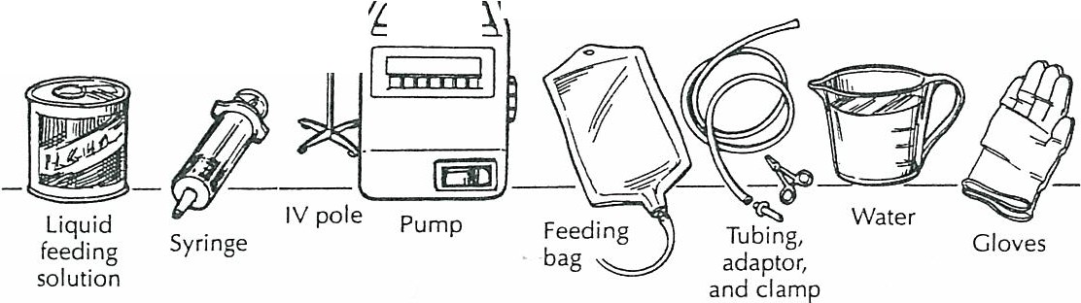

    - Liquid feeding solution /form ula at room temperature
    - 10-ml or -cc syringe
    - Feeding pump (optional)
    - IV stand (optional)
    - Clamp or cap for end of tube
    - Water (if prescribed)
    - Feeding bag
    - Safety pins
    - Gloves (optional)
  - Explain the procedure to the student at his or her level of understanding. Encour­ age the student to participate as much as possible.
  - Position student.

  - Wash hands. Put on gloves.
  - Pour feeding/fluids into feeding bag and run feeding through bag and tubing to the tip. Clamp.

  - Han g bag on pole at height required to achieve prescribed flow. Place tubing into feeding pump mechanism and set for proper flow rate.
  - Insert tip of feeding bag tubing into jejunostomy tube and tape securely. Unclamp f-tube.

Identify size and type of !-tube. Some students get cramps if the feeding solution is too cold.

Used to flush tubing after feeding. Used to secure !-tube to clothing.
By encouraging the studen t to assist in the procedure, the caregiver helps the student achieve maximum self-care skills.

Student may be sitting or lying on right side with head elevated at a 30-degree angle. When positioning the student, make sure clamp is not pressing on skin. Tubing may be pinned to shirt. Remember to unpin [-tube before proceeding with feeding.

If medication is prescribed, administer before or after feeding according to student-specific guidelines and flush tubing well before start­ ing feeding.
School activities may continue during feeding
provided the student is sedentary.

Do not apply undue traction on jejunostomy tubing.

  - Vent G-tube or skin-level feeding device if
indicated during feeding.
  - Set flow rate on pump.

  - Add more fluid to bag before it is com­ pletely empty.

12.. If feeding is completed during school time, then clamp feeding bag tubing and clamp J-tube.

- Disconnect feeding bag from J-tube.
- Unclamp J-tube and flush with water using a syringe.

- Clamp and cap J-tube.
- Apply dressing, if needed, using universal precautions (see Chapter SJ.
- Make sure tubing is secure and tucked inside clothing. Tubing may be pinned to shirt.

- Wash feeding bag, tub ing, and syringe in tap water and store in a clean area.
I

I
May need syringe or drainage bag for venting. i
Check pump periodically for proper infusion rate.
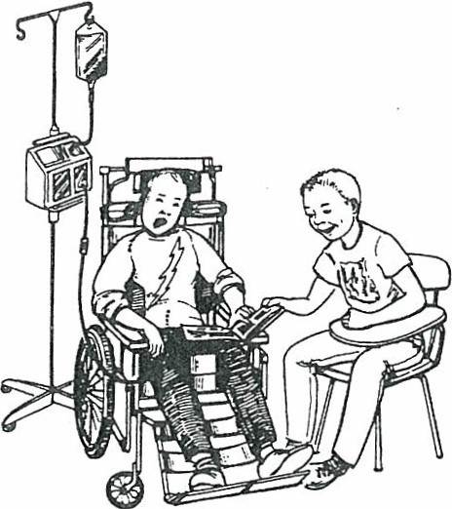
Be alert to any changes in the student's tolerance of the feeding. Nausea/vomiting; cramping; pale skin color, sweating; irritability, or diarrhea may indicate that the feeding is beinggiven too quickly or formula is too cold.

Amount of water used for flush may vary according to student-specific recommenda­ tions. This clears the tubing of any feeding fluid.

Remember to unpin tube before removing shirt. The feeding may be disconnected while the student is being transported to and from the school program.
Most open formula is good for 48 hours. The exceptions are some elemental formulas that are good for only 24 hours. Open formula should be stored in clean plastic containers (not the original can}, labeled correctly, in the refrigerator. Formula should be discarded after 48 hours.

2.0.
2.1.

2.2..
Remove gloves.
Wash hands.
Refe r to student-specific guidelines regard ing activity aiter feeding.
Document feeding/medication and feeding tolerance on log sheet.

Report to family any change in the student's usual pattern.

Possible Problems that Require Immediate Attention

Observation
Color changes/breathingdifficulty

Sweaty skin, pale skin color, increased heart rate, irritability, diarrhea

Nausea and/or cramping

Vomiting

May see jejunal feeding contents in G-tube drainage

Blocked jejunostomy tubing

Bleeding/drainage J-tube falls out

,

Reason/Action

Some students may have increased upper air­ way secretions with feedings and may need suctioning. Stop feeding and follow stizdent­ specifi.c instructions for suctioning.
Signs of dumping syndrome. This can occur when caloric intake and/or volume of feed­ ing are increased. If this is a new occurrence, stop the feeding until symptoms subside.
Notify family of these symptoms. Follow student-specific guidelines.
Check rate of feeding-rate may need to be decreased .
Check temperature of feeding- feeding may be too cold: Stop feeding, let feeding get to room temperature, then administer. If problem continues, notify school nurse, doctor, and family.
fejunostomy tube may be dislodged from jejunum. Stop feeding; notify scho• 11urse, doctor, and family.
The jejunostomy tube may not be in the proper position. If all of the above have been checked, stop feeding; call school nurse, doc­ tor, and family.
May need to vent G-tube if it was clamped during jejuna] feeding.
!-tu be may be dislodged from jejunum. Stop feeding, notify school nurse, doctor, and family.
May be due to inadequate flushing or very thick fluid. Squeeze or roll tubing with fin­ gers, moving slowly down toward stu dent' s stomach. Try a 3-cc syringe fi.lled with warm water held high to facilitate movement of fluid. If blockage remains, do not apply force. Contact school nurse and family.
Make sure tubin g is not being pulled. Check the !-tube site for leakage.
In some students, whose tracts may close quickly, the [-tube may need to be reinserted wi.thin 1-2 hours.
Cover the site wi.th dry dressing or large bandage. Notify the family.

SUPPLEMENTAL OXYGEN USE

PURPOSE

Oxygen provides for body functions, relieves shortness of breath, and reduces the work­ load of the heart. Oxygen use is indicated for physical conditions in which a student is unable to get enough oxygen into the body or needs more oxygen, such as chronic lung conditions (e.g., bronchopulmonary dysplasia [BPD],·cystic fibrosis [CF], heart problems).

SUGGESTED SETIINGS
When in contact with a student using oxygen, the following warning is in effect:
WARNING:
  - THERE SHOULD BE NO SMOKING, OPEN FLAME , OR HEAT SOURCE CLOSE TO THE OXYGEN; THESE MAY INCREASE THE RISK OF FIRE.
  - EQUIPMENT AND OXYGEN SUPPLY MUST BE CHECKED AT LEAST DAILY, OR MORE OFTEN, DEPENDING ON THE EQUIPMENT.

SUGGESTED PERSONNEL AND TRAINING
A health assessment must be completed by the school nurse. State nurse practice regu­ lations should be consulted for guidance on delegating health care procedures.
The school nurse or other adult with proven competency-based training in appropri­ ate techniques and problem management may administer oxygen through a nasal can­ nula or mask. Use of a tracheostomy collar may require a registered nurse or respiratory therapist with training, depending on the care needs of the stu dent with a tracheostomy. Any school personnel who have regular contact with a student who requires oxygen must receive general training that covers the student's specific health care needs and potential problems and must understand how to implement the established emergency plan.
The basic skills checklists on pages 351- 354 can be used as a foundation for compe­ tency-based training in appropriate techniques. Specific procedures for oxygen use are outlined step by step. Once the procedures have been mastered, the completed check­ lists serve as documentation of training.

THE INDMDUALIZED HEALTH CARE PLAN: ISSUES FOR SPECIAL CONSIDERATION
For a student who requires oxygen, the following items should receive particular attention:
- Student's underlying condition and possible problems associated with the condition or treatment
- Oxygen safety precautions including posting of "oxygen in use" warnings
- Spare oxygen supply and saie storage when not in use
- Adaptation of classroom for necessary equipment, storage, and transport (e. g., length of tubing, oxygen source)
- Signs and symptoms shown by the student when not receiving adequate oxygen (e.g., cyanosis, agitation, distress)
- Student's baseline status, including color, respiratory rate, pulse, and blood pressure
- Student 's ability to request oxygen or assistance
- Percentage and/or liter flow of oxygen prescribed (for daily use and emergencies )
- Access to oxygen supply throughout school building (i. e., portable or sta tionary)
- Latex allergy alert .
- Universal precautions (Anticipating the tasks to be done, the risk involved, and the personal protective equipm ent needed will enhance protection of both the caregiver and student)

OXYGEN SAFElY PRECAUTIONS

- Do not smoke or allow open flames near oxygen. Store oxygen away from heaters, radiators, and hot sun.
- Never permit oil, grease, or highly flammable material to come into contact with oxy­ gen cylinders, liquid oxygen, valves, regulators, or fittings. Do not lubricate with oil or
- other flammable substances, and do not handle equipment with greasy hands or rags.
- Never put anything over an oxygen gas tank.
- Know the name of the home oxygen supply company contact person. Have the tele­ phone number posted in an obvious place and on the emergency plan.
- Return any defective equipment to the authorized company for replacement.
- Have spare oxygen readily accessible based on the stu dent 's needs. This should be stored safely in a secure place.
- Keep extra tubing and tank equipment (e.g., wrenches) in an easily accessible place.
- Protect dry regulator from becoming dislodged. A hissing noise may indicate a leak in system.
- Be sure that the tank (w hen using oxygen gas) is securely placed in its stand and can­ not fall or be knocked over.
- Be careful that the oxygen tubing does not become kinked, blocked, punctured, or dis- connected.
- Use only the flowmeter setting prescribed by the student's physician.
- Notify the fire department that oxygen is in use in the school.
- Secure the oxygen tank or liquid system for transpor t in an upright position. Make sure the gauge and valve stem are protected from damage.

OXYGEN SOURCES
Oxygen gas Pure oxygen gas is stored under pressure in a metal tank or cylinder. Tanks come in different sizes, ranging from small (po rtable) to large (stationary). The tank size used by the student depends on the amount of oxygen flow needed. The
amount of oxygen available in the tank is indicated by the pressure gauge on the tank.

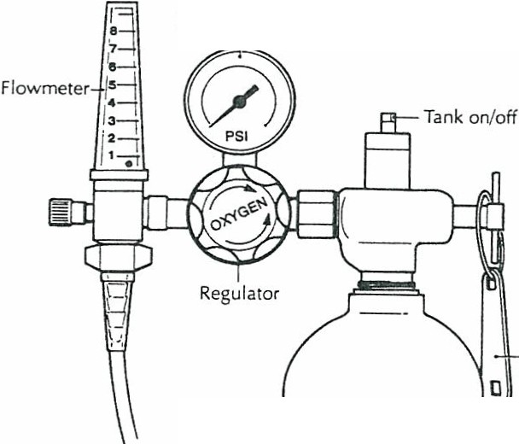
Pressure gauge
On/off
wrench
0 2 ta nk

Oxygen concentrator This is an electronically powered machine that removes nitro­ gen from room air and concentrates the remaining oxygen for delivery to the stu­ dent. This type of system delivers a lower concentration of oxygen at low liter flows. An oxygen concentrator requires an electrical outlet and is not portable. Some units maycontain a back-up battery in the event of a power failure . Each unit hasanair filter that requires periodic cleaning.
Additional equipment for oxygen concentrator systems includes the following:
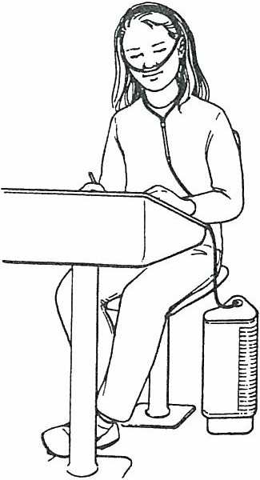
  - Humidification source
0 Oxygen tubing, mask, cannula, or tracheostomy collar
  - Emergency oxygen tank for power failure
Oxygen liquid Oxygen liquid systems utilize a ther­ mal storage container that keeps the pure oxygen as a liquid at -300° Fahrenheit. A smaller portable container (i . e., thermos) usually is used to deliver the oxygen to the student. Depending on the pre­ scribed liter flow for the student, the thermos may require refilling from the larger storage tank.
Additional equipment for both gas and liquid systems includes the following:
  - Tank stand or carrier
  - Regulator with pressure gauge and flowmeter
  - Wrench for gas tank valve
  - Humidification source
  - Oxygen tubing, mask, cannula, or tracheostomy collar

Possible Problems that Require Immediate Attention for Students Requiring Oxygen

Observations
The student shows any of the following signs of respiratory distress:
- Shortness of breath or rapid breathing rate
- Agitation
- Blueness or pallor of the lips, nails, or ear­ lobes
- Pulling in of the muscles at the neck or
chest
- Confusion, dizziness, or headache
- Rapid or pounding pulse

Reason/Action

Stay calm and reassure student.

Check student:
- Position student to open airway. Make sure mouth, nose, or tracheostomy tubeis not obstructed by food or mucus.
- Check tracheostomy tube placement.
- Make sure collar is not out of position or obstructing tracheostomy tube.

Check equipment (check oxygen flow-if flow is weak or inadequate):
- Make sure tank is not empty or defective. If so, replace with back-up tank.
- Make sure valve, regulator, and flowme­ ters are on proper settings.
- Make sure tubing is not blocked or kinked.
- Check all connections from oxygen source to student.
- Make sure tubing, mask, cannula, and col­ lar are not blocked.
- Make sure humidifier bottle is properly attached.
- Make sure tubing is not obstructed by water collecting in it from condensed mist. Empty water from tubing frequently when using mist.

The equipment and oxygen flow are adequate, but the student continues to show signs of respiratory distress, becomes unconscious, or has a respiratory arrest.

Initiate emergency procedure ana not1ry ram­ ily. Begin cardiopulm onary resuscitation i f needed.

Observation

A Possible Problem that
Does Not Require Immediate Attention
Reason/Action

Redness, dryness, or bleeding of the skin

May be due to irritation from the device or from in sufficient humidit y.
Notify family to discuss problem with physi­ cian.
Never use powders or petroleum products on the
student's face.

TRACHEOSTOMY

l"URPOSE

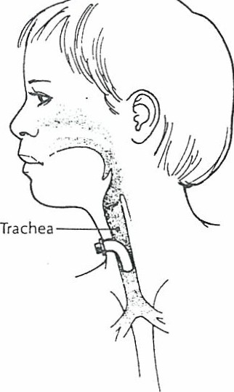A tracheostomy is a surgical opening in the neck into the trachea (windpipe), which allows air to go in and out of the lun gs. The opening in the neck is called a stoma. A metal or plastic tube, called a tracheostom y tube, may be inse rted through the stoma into the trachea; some students may not need a tracheostom y tube. There are various types of tra­ cheostomy tubes that are held in place with a tie around the neck.
Some students will have a tracheostomy because of an injury or condition that requires bypassing the norm al breathin g passages. Others require a tracheostomy because of n eurolo gical, muscular, or other conditions that make it difficult for them to breathe effectively or to clear secretions or mucus out of their breathing passages wit hout assistance. A tracheostomy allows long-term access to a ventilator or respirator (i.e. , breathing machine) and an easy way to clear
the trachea of mucus. Many students with tracheostomies are able to speak. Most are able to eat and drink by mouth but may need dietary modifications.

SUGGESTED SETTINGS
Students with tracheostomies, in most cases, can attend classes in general classrooms. Some may need to be accompanied by a trained caregiver at all tim es in the educational setting or during transport. Many students with tracheostomies participate in school activities with modifications that should be determined by the family, physician, school nurse, and school staff. All staff in contact with students with tracheostomies should have specialized cardiopulmonary resuscitation training. They should be able to recog­ nize signs of breathin g difficulty and should know how to activate the emergency plan for their setting.
Students with tracheostomies should avoid areas with a lot of dust or other airborne particles, such as chalk dust. Such areas should be avoided because the air the student breathes enters the lungs directly without being filtered, humidified, and warmed by the nose and mouth.
Regular tracheostomy care prescribed to maintain the student's health and function should be done at home. If additional regular care is required, however, it should be done in a private, clean area, such as the health room. In an emergency, care should be given wherever the student is. Therefore, it is imperative that a complete set of equip ment for tracheostomy care, incl uding all item s in the go-bag (p. 355) and suction machine be with the student at all times.

SUGGESTED PERSONNEL AND l'RAINING
A health assessment must be completed by the school nurse. State nurse practice regu­ lations should be consulted for guidance on delegating health care procedures.
Trache al care for students who require care in school, such as suctioning, saline instillation, useof a tracheostomy collar, or other daily care, shouldbe provided by a reg­ iste red nurse or licensed respiratory therapist unless state medical and nursing practice standards specify otherwise. These caregivers should have proven, competency-based training in appropriate techni ques and problem management. All staff in contact with students with tracheostomies should have specialized cardiopulmonary resuscitation training. They should be able to recognize signs of breathing difficulty and should know how to activate the emergency plan for their setting.

There are different service delivery models available for tracheostomy care that involve nonmedical personnel. The recommendations herein are conservative and are based on the following issues:
  - The lack of standardization in nursing and medical practice
  - The highly technical nature and potential risk to the student
Under some circumstances, after a student with a tracheostomy has been in the school setting for a period of time and it is clear that the student's medical condition is stable, it may be appropriate for the health care team and the family to consider using a nonmed­ ical caregiverwho has received appropriate training and supervision by a school nurse who is in the building at all times.
Some students need less frequent care or require no routine tracheostomy care at all. The decision regarding the placement of the caregiver for such a student must be made by the family, physician, and school nurse and be based on the student's medical condition, tracheal care needs, and adaptation to school. Other considerations should include the varied locations of the student in the school, the school nurse-to-pupil ratio, and a school nurse being in the building at all times.
If the trained caregiver and back-up personnel are unable to be available on a given school day, the student should not attend school. However, an optional arrangement could be made between the school and the family so someon e from the family would be available to attend school to function as the caregiver for the student.
Any school personnel who have regular contact with a student with a tracheostomy must receivegeneral training that covers the student's specific health care needs, poten­ tial problems, and how to implement th e established emergency plan.

THE INDMDUALIZED HEALTH CARE PI.Al"'i: ISSUES FOR SPECIAL CONSIDERATION

For a student who receive particular attention:
-
req

uires tracheal care, the following
- -
items should

  - Student's underlying condition and possible problems associated with the condition or treatment
  - Student's baseline status (e.g., color, respiratory rate, pulse, blood pressure, secretions)
  - Student's care requirements (e. g., suctioning)
  - Student's ability to request assistance
  - Student's proneness to emergencies
  - Signs and symptams of re spira tory distress shown by this student
  - Type of tracheostomy tube used (e.g., inner cannula, cuffed)
  - Accessibility to equipment and back-up equipment
  - An alternate means of warming and moisturizing the air may be necessary at times to prevent the mucus from becoming too thick
  - Student's need for additional fluids
  - Student's speech may be affected-alternative means of communication may be nec- essary (i.e. , American Sign Language, Passey-Muir valve, communication board)
  - Personnel and equipment neededfor transportation (e.g., travel bagl
  - Availability of caregivers
- Staffing needs to provide care for the student (one to one)
- Means of communication (e.g., walkie-talkies, intercoms, telephones) among differ­ ent areas of the school
- Latex allergy alert
- Universal precautions (Anticipating the tasks to be done, the risk involved and the personal protective equipment needed will enhance protection of both the aregiver and student.)
. Do ot use powders; aerosols (i.e., room deodorizers); small particles, such as sand, itter, t, chalk dust, and animal hair; small pieces of food and water; or glue or chem­ ica s with strong fu es near a student with a tracheostomy. Students who may have a_ccidencal_ contact with any of these potential hazards should have some kind of protec­ tive covenng for the tracheostomy.

NEBULIZER TREATMENTS

PURPOSE

Nebulizer treatments deliver medication in mist form directly into the lungs. When air from the compressor (i.e., air pump) is pushed through the tubing and into the medicine chamber (i.e., nebulizer cup), the medicine breaks up into a mist that the student inhales. Small dosages of medication inhaled directly into the lungs cause fewer side effects than the same medication taken in oral form. Medication by nebulizer also reaches the bronchioles more rapidly, and less coordination and breathing effort are required than when using a metered dose inhaler.
Aerosol treatments are beneficial for children who are too young to master the metered dose inhaler and for students with moderate to severe astluna whose lungfunc­ tion is greatly impaired. Nebulizer treatments also are used to deliver antibiotics and other medications.

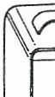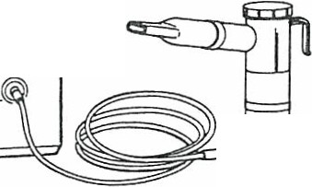SUGGESTED SETTINGS
\
8
Select an area such as a health room or office for privacy. The air com­ pressor may be moderately noisy. A nebulizer unit is attached to the air outlet on the compressor. It consists of the nebulizer cup, which holds the medicine, and the nebulizer, which
produces the mist. A T adaptor, placed on the nebulizer, passes air to the mouthpiece and allows exhaled air to pass out.
The mouthpiece is placed between the teeth and allows for a tight seal with the lips. A face mask or a tracheostomy mask can be used instead of a mouthpiece and attaches directly to the nebulizer unit. The connecting tubing connects from the end of the nebu­ lizer unit to the air outlet of the compressor.
Note: Nebulizer units vary in design, which affects the size and speed of the mist particles and length of treatment. Some units are more durable and can withstand greater use and cleaning.
A power-driven air compressor is available in different models. All have the same basic features: an air outlet, to which the nebulizer tubing is connected; and an air inlet, which pulls air into the compressor through a filter.
The filter needs to be kept clean and should be replaced periodically.

SUGGESTED PERSONNEL AND TRAINING
A health care assessment must be completed by the school nurse. State nurse regula­ tions should be consulted for guidance on delegating health care procedures.
A nebulizer treatment may be administered by the school nurse, family, teacher, student aide, or other person with proven competency-based training in appropriate techniques and problem management. Before deciding on the appropriate person to administer the treatment, information about state regulations and school policy for med­ ication administration in school must be considered. Medication administration protec­ tion measures (e.g., use of filters in the exhalation port, tightly fitting mask during treatment), if indicated, also should be followed. The student should be encouraged to assist with the nebulizer treatment as much as possible. Any school personnel who have regular contact with a student who requires a nebulizer treatment should receive general training that covers the student's specific health care needs, potential problems, and how to implement the established emergency plan.

THE INDMDUALIZED HEALTH CARE PI.AN: ISSUES f'OK SPECIAL CONSIDERATION

For a student who requires nebulizer treatment, the following items should receive particular atten tion:
0 Need for student to receive nebulizer treatment
  - Need for activity modincations
  - Knowledge of guidelines and protective measures specific to the medication being administered
  - Knowledge of allergens and triggers of wheezing for students with asthma
  - Student's self-care skills
0 Student's school attendance/absences related to increase in episodes of respirato ry dis- tress
  - Need for peak flow readings before treatment
  - Student's knowledge of early signs of respiratory distress
  - Need for chest physical therapy and/or suctioning
  - Treatment administration as "regularly scheduled11 or "treatment as needed"
  - Response to treatment and necessity for repeat treatments (per physician or nurse practitioner's order)
  - Lat ex allergy alert (see Chapter SJ
  - Universal precautions (An ticipa ting the tasks to be done, the risk involved, and the personal protective equipment needed will enhance protection of both the caregiver and student .)

PROCEDURE FOR AEROSOL TREATMENT BY NEBULIZER WITH AIR CoMPRESSOR

PROCEDURE
I. Determine need for treatment based on specific physician's or nurse practitioner's order. The student may ask for treatment.
- Wash hands.

- Assemble equipment:
POINTS TO REMEMBER

Assess student's status: respiratory rate, depth, effort, pulse, restlessness, color, retractions, cough, and wheezing.

Anticipating the tasks to be done, the risk involved, and the personal protective equi p­ ment needed will enhance protection of both the caregiver and student.
I
I

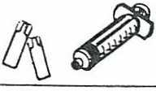
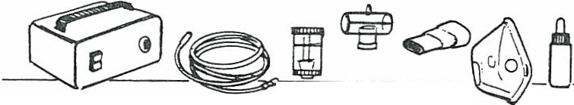I
Compressor
Tubing
Nebu- T tube Mouth­
lizer
Medi-
piece Face ca t oi n

cup

mask
Saline dosettes
Syringe

  - Compressor/gas cylinder
  - Connecting tubing
  - Nebulizer cup
  - Mouthpiece or mask, T adaptor
  - Medication
  - Diluting solutio n
  - Saline dosettes
  - Syringe
Filter disc/exhalation filter, if needed
- Place the unit on a furn, flat surface.

- Attach the end of the nebulizer tubing to the compressor's air outlet. Unscrew the top from the nebulizer cup.
- Place the prescribed amount of medicine and diluent into the nebulizer cup.
- Reattach the nebulizer cap tightly.
- Attach the connecting tubing to the nebu­ lizer cup outlet.

Some compressors are electrically powered . Others are battery operated.

Some medications donot require diluent solu­ tion.

- Have the student sit in a comfortable posi­ tion.

- Turn on power switch.

- Have student place mouthpiece in mouth between teeth and seal lips around mouth­ piece or place mask over nose and mouth (or trach eostomy).
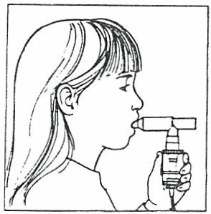
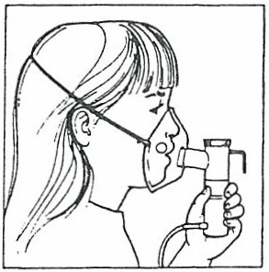

- Have student begin to breathe in through the mouthpiece or mask.

- Every 1-2 minutes have studen t take a deep breath , hold breath briefly, then exhale slowly and resume normal breath­ ing.

- At the end of treatment tum off power switch.
- Remove mouthpiece or mask.
- If ordered, have student take several deep breaths, and cough up secretions.
- Assess student's respiratory status.

- Disassemble equipment.
- Refer to cleaning instructions.
- Wash hands.
- Document treatmen t.

- Cleaning and care of equipment: After every use, rinse nebulizer assembly, mouthpiece , and mask under warm run­ ning water for 30 seconds. Shake off excess water. Lay on clean cloths to dry. Cover with cloth or paper towel. When parts are dry, store them in a clean plastic bag. Fol­ low manufacrnrer's instructions regarding replacement of filter. Do not wash tubing. Once or twice a week: Clean nebulizer parts more thoroughly. Soak parts in solu­ tion of 1 cup white vinegar and 2 cups warm water for 30 min utes. Rinse thor­ oughly after soaking. Alternatively, parts may be sterilized by boiling or may be cleaned in dishwasher. See product instruc­ tions accompanying the unit.

Encourage stuaent to part1c1pate m tne proce­ dure. Assess student 's pulse and respiiatory rate.
A fine mist should be visible.

If a student is able to use mouthpiece for treat­ ment, he or she should be encouraged to take
l

slow, deep breaths during entire treatment. I
I
I
I
I

Note: This illustration does not apply to stu­ !
dents receiving medications that need a fil­ ter in exhalation port or tightly /i.tting mask during treatment.

Have student breathe at a normal rate and depth. Observe the expansion of the stu­ dent's chest.
Deep breaths ensure that the medicine is being delivered to the lower airways, not just the mouth. A treatm ent may last
10-15 minutes . Give student time to rest during procedure if needed . If mist stops and medicine can be seen on sides of cu p, tap side of cup. and the mist should start again. Allow all medicine to aerosolize.

Ii student still is having difficulty breathing or is wheezing, follow student-specific plan.

Report to family any changes in the student's usual pattern of tolerating the procedure.
i\foy be done at home. Cleaning the equipment prevents clogging and malfunction and reduces infection. Student-specificnebulizer cup, tubing, and mouthpiece can be reused after cleaning. Compressors can be used for multiple students.

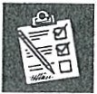
About Asthma --- -

Asthma is the most common chronic disease of chil­ dren. It is a condition that affects the large and small breathing tubes (bronchi and bronchioles) of the lungs. For some reason the breathing tubes of persons with asthma are "twitchy" and react more than those with­ out asthma. This means that certain "triggers," such as colds and cigarette smoke, can irritate the breath­ ing tubes and make the airway smaller.

How do these triggers make the airway smaller?
When the triggers irritate the breathing tubes, three things happen that make the airway smaller:
- The lining of the bronchioles swells.
- The muscles around the bronchioles become tight.
- Glands in the breathing tubes make more mucus.

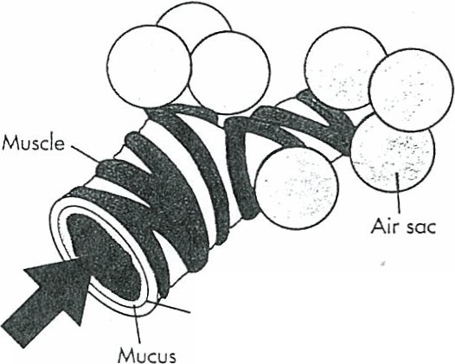Normal bronchiole
Lining of bronchiole
Air
Children with asthma wheeze, cough, and have trouble breathing. Wheezing is the sound of air pass­ ing through the smaller breathing tubes. Coughing oc­ curs as the body tries to get rid of the mucus in the airway. Children have trouble breathing because it is hard for air to get in and out of the smaller airways. A child with these problems is having an asthma attack. We do not know what makes a child have asthma, but we do know that a child with allergies is more likely to get it. Asthma also tends to run in families.

How are asthma attacks treated?
Your child will take medicines called bronchodilators to make the breathing tubes bigger. He or she may also take a medicine known as a steroid to lessen the swelling of the breathing tubes. Asthma medicine is given by aerosol (mist or spray) so it can get into the lungs quickly. Make sure you give this medicine for as long as your health care provider says.
Allow your child to rest, and give him or her lots of clear liquids to drink. The liquids will keep the lung's mucus from being sticky.
Your child will take medicines to decrease the num­ ber of asthma attacks that occur. Thesemedicines will be given by mouth or by aerosol.

- Muscle tightened cousi_ng narrowed rnr passage or
11b roncho-constri ction 11

Bronchiole during flare

a ,r sa c

Do children outgrow asthma?
Asthma usually gets better as children grow up. This is especially true of children who get asthma as babies and do not have obvious allergies. This happens, in part, for the following reasons:
- The breathing tubes get bigger as the child grows. This means that the reaction to a trigger does not block air flow as much.
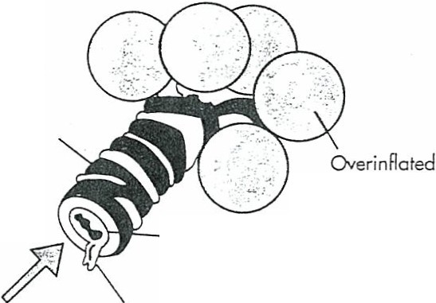
- Children do not get as many colds and respiratory infections as they did in infancy and preschool. Children with bad asthma may continue to have at­
tacks, but they tend to show some improvementdur­ ing puberty.

Air
Edema (swelling_ o f the lining of
the bronchial tube)
Mucous secretion increased

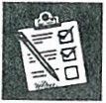
Identifying Asthma Triggers -

A child with asthma or reactive airway disease has airways
{breathing tubes) that are very sensitive. They may react to asthma triggers, which are things that can cause asthma at­ tacks. Staying away from these triggers will help keep your child's asthma from getting worse. Asthma triggers include
(1) things that cause allergic reactions or itching, (2) thing s that botheror irritate the lungs, (3) colds and infections, (4) exercise, (5) stress, and (6) weather changes.

Outdoor Asthma Triggers
- Pollens. Pollens arrive on a fairly regular schedule; tree pollen occurs first and is followed by grass and weed pollen. Find out when your pollen seasons start and end.
- Molds. Outdoor molds are found in piles of leaves, damp areas around the outside of the house·, and in very shaded areas.
- Weather changes. Changes in either the temperature or the humidity may trigger an asthma attack.
Indoor Asthma Triggers
- House dust. We are all around house dust every day. It is made up of many particles. including ordinary house dust, the house dust mite, animal dander (hair and skin flakes), and cockroach particles. The presence of house dust does not mean your home is "dirty." The house dust mite alone can cause asthma attacks and is found throughout the home in mattresses, pillows, carpets, up­ holsteredfurniture, bed covers, and s uffed toys.
- Animal dander. Some people are allergic to the saliva, the urine. or the dried flakes of sk;n from warm-blooded pets. Warm-blooded pets include ALL breeds of cats, dogs, birds, and rodents. There are no "nonallergenic" dogs or cats, and the length of the pet's hair does not matter. Remember that school trips to petting farms or zoos may trigger a child's asthma.
- Molds. Indoor molds are found mostly in bathrooms, kitchens, and basements because theseare the damp ar­ eas in most homes. Specific items that may have mold on them include pillows made of foam, which collect sweat and allow mold to grow. In the kitchen, garbage contain­ ers and water pans in the refrigeratorcan collect mold. In the bathroom,shower curtains. bath tiles, and the tub fre­ quently gathermold. Indoor plants alsohave mold spores in the dirt.
- Cockroaches. Cockroach droppings can cause aller­ gies and trigger asthma attacks. Cramped living areas are the best environment in which cockroaches breed. Cock­ roaches live in areas that are unclean , such as in kitchen areas where food is uncovered or in trash cans.

Things that bother or irritate the lungs
- Tobacc o smoke. The most significantindoor irritant is , tobacco smoke. Tobaccosmoke is made up of very small particles that remainin the air for long periods of time and have been shown to be harmful to the lungs of both chil­ dren and adults.
- Woodstoves. As the hot, smoke filled air from wood­ stoves rises up the chimney, cold air is drawn from the rest of the house into the stove. This air is replaced by outside air that has the smoke that has just left the chim­ ney. Even a tight wood stove brings sooty air into the home. These stoves should not be used to heat a home in which children with asthma live.
- Strong sprays and fumes. Any odor or fume, such as strong household sprays, may triggerasthma symptoms. Strong sprays include hair sprays, talcum powder, per­ fumes, paints, gasoline, scented soaps, and cleaning sprays. Strong cooking odors (especially thosefrom fry­ ing) may also trigger asthma symptoms.

Other Asthma Triggers
- Colds and infections. A cold or flu infection is one major trigger for children.The virus causing the cold or flu can irritate sensitive airways and trigger asthma symp­ toms.
- Exercise. Regular exercise is important for the physical and emotional development of children. Exercise­ induced asthma can be prevented with medication. Swimming, skiing, and touch football are types of sports that cause no or relatively mild asthmasymptoms.
- Stress. Some doctors believe that stress can trigger an asthma attack in children. Stressful events such as mov­ ing to a new home, going through parents' divorce, expe­ riencing school problems, or the addition of a new brother or sister may lessen the child's ability to prevent asthma symptoms when other triggers are irritating the airways.

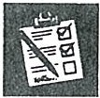
Identifying a _S_e_vere Asthma Attack

a severe asthma attack can develop over many hours, or it can occur very suddenly. Some­ times an attack becomes so severe that you need to go to the doctor or hospital. You can tell when an at­ tack is severe if your child has these signs:
  - Takes two times as long to breathe out as to breathe in
  - Has very fast breathing and shortness of breath
  - Uses stomach, chest, and neck muscles to get air (see figure)
  - Has flared nostrils with bluish lips and mouth
  - Has chest that looks bigger _
  - Leans forward with shoulders up high and refuses to lie down
  - Cannot say more than a few single words or short phrases between breaths
  - Becomes less alert
  - Has a peak flow score less than half of his or her "b est"
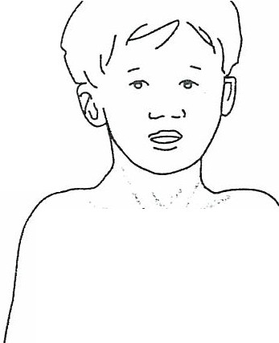

--0 -·'
, ,.....

SEIZURE IDENTIFICATION CHART

Type What seizures
look hKe

Do Don't

(;cncrnlizcd Tonic Clonic
(Grand l\lnl)

Absence

(Petit Mal)

Complex Purlial (Psychomotor, Tcm1mrul Lobe)

Other Seizure 'l)'pcs
•Aura - (warning , start of seizure)
•Fall to ground
•Tonic phase - stiffening
•Clonic phase - jerking
•May have shallow breathing and skin may be slightly blue
•Lasts I to 2 minutes
• Recovery - tired, confused, may need rest

•Looks like blank stare/ daydreaming
• Brief (few seconds), blinking, chewing
- Person unaware

•Blank stare, disoriented, chewing movements, confu-:"ln, may wander,
pick at ci\)thes, not respond
• Lasts several seconds to a fcw minutes, no memory of event
•Seizure may be confused with drugs or drunkenness, n'aenral illness, disorderly conduct
•Stay calm
•Protect head f, r· m injury
• Place person on side (lo keep airway clear)
•Look for medical idcntification
- Note the time
•Loosen collar
•Clear the area
•Stay with person until seizure is over and reassure them

- No first aid needed
•Family should be made
aware that seizure took place

•Speak calmly, reorient
•Reassure person who has had seizure
•Guide away from dangerous objects
•Stay with until consciousness
returns
·Do not put anything in mouth
•Do not call amhulance unless more than 5 minutes
have elapsed or the person has injured him/herself.
is pregnant. has diahctes or has a series of seizures.
•Do not perform artificial respiration

•Do not restrain

Simple Pnrliul •Local jerks, a local sensation
.•
• No first aid needed
•Family should be made
aware that seizure took place

Atonic
I\ Iyoclonit:
Infantile spasms
•Drop attacks
•Sudden jerks
•Cluster of quick jerks
• Notify physician

