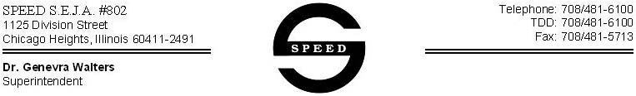

Dear Parent/Guardian: Date:________________________

Your child had a _______________________________________ Procedure Plan on file. For the next school year, enclosed are the following forms:
*Medical Procedure authorization Form for Gastrostomy Tube feeding
*Medication Aurthorization form
*Gastrostomy Tube feeding supply letter

Also one of these forms, if needed, may be included:
*Seizure Action Plan by the Epliepsy Foundation
*Daily Asthma/Allergy Management Plan by the Asthma and Allergy Foundation of America

Please provide the appropriate form (only if needed) to your child’s doctor for written orders and their signature. Also, complete and sign the parent’s authroization section. Any other medical information you provide to us is beneficial.

We request and encourage a parent demonstration of all medical interventions that are to be given at school (including medication).

NO MEDICATION OR PROCEDURES WILL BE ADMINISTERED AT SFHOOL WITH A DOCTOR’S ORDER.

Written medication administration and medical procedures guidelines are provided in the SPEED student handbook/calendar.

Please return the forms to school ASAP in person or fax the information to us. Our fax number is:___________________.

Thank you
SPEED Certified School Nurses
Telephone number:_____________________

