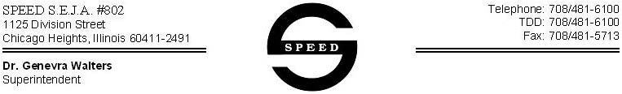

PROCEDURE LOG

Student Name:__________________________________School Year:__________________

INIT. | NAME | TITLE

DATE | TIME | INIT | PROCEDURE | AMT. | COMMENT

DATE | TIME | INIT | PROCEDURE | AMT. | COMMENT

