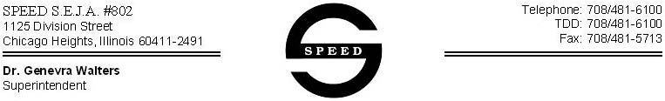

Dear Parent/Guardian:

The supplies for your child who is receiving Gastrostomy tube feedings at school are required to be sent in at least weekly. Additional supplies can be sent and stored here at school if it is convenient.

Supplies needed include:

- Student’s formula in the unopened, original packaging. (i.e. Pediasure, Ensure, etc.)
- New feeding bag or syringe (when applicable) and at least one spare bag
- G-tube adapters for a weekly change

If the needed supplies are not available on the first day of the school week, the parent will be called to deliver the supplies prior to the time of the feeding.

During the week, the bags and adapters are washed, rinsed and stored in the refrigerator in individual containers after use and remain at school. The supplies are disposed of on the last day of the school week.

If the Gastrostomy tube falls out at school, the school nurse will contact you to determine how to proceed.

If you have any questions or concerns, please contact:_________________________________at
____________________________________.

Thank you,
SPEED Certified School Nurse

